General information about the word processor, the program interface. Creating and storing documents
The purpose of the lesson:
Knowledge:
Increase students ' knowledge of creating and storing documents by teaching them the MICROSOFT WORD Word Processor.
Development:
Formation and storage of documents training in competent use in practical work. Introduction to the use of computer knowledge in life.
Educational:
Development of students ' skills of compactness, punctuality, working with the Topp, correct decision-making with the competent use of an electronic computer.
Lesson type: effective use of game elements.

Visual aids and additional materials used in the lesson: electronic textbook, notebook, Watman, sticker, interactive whiteboard, computer, cards.
Lesson progress:
1) organizational stage. (Greeting, inventory) security rules
2) checking the assignment given to the House. Let's think (repeat questions) 3) explain a new topic
"Find out»
1) Creative Work (message)
2) How does Microsoft WORD start the word processor?
3) Find window elements
4) toning moment (Fizminutka)
5) Venn diagram
4) Approval
Question – answer" Find Me "5) assessment of students' knowledge.
6) homework assignment:
7) conclusion
Safety rules
Do not enter and leave the classroom without the teacher's permission!
Do not enter the office in outerwear!
Do not run, play in computer class!
Don't run water manually on your computer!
It is forbidden to touch wires and sockets!
Do not eat in the computer science cabinet!
If there is a burning smell, immediately inform the teacher!
Do not chew gum in the classroom!
Do not put anything on the keyboard!
Keep your back straight and try to sit up straight.
When working with a computer, the distance between the eyes and the screen should be 60-70 CM.
Do not forget to do eye exercises if your eyes are tired

2) Let's think (repetition questions)
As you answer questions, the topic of today's lesson will gradually be formed. The answer to each question you find is equal to one word of our topic.
• What is the model?
* What is modeling?
* Classification of models.
* What is the model used for and for what purpose, depending on the application area?
• What is the training model?
* What is an experimental model?
* What is a logical model?
* How many stages does modeling consist of? • What should be shown in Stage 1 of the simulation?
That's right, and now let's move on to the topic of our lesson today.
The theme of our lesson is "general information about the word processor, the program interface. Creating and storing documents»

3) explanation of a new topic
"Find out»
A word processor is a type of application computer program designed to create (type, edit, format, and sometimes print) any printed information.
Word processors have great text formatting capabilities. It can add various images, graphs, drawings, and tables to the document. different processors have a set of functions for working with text.
The processor screen includes all elements of the standard Windows window:
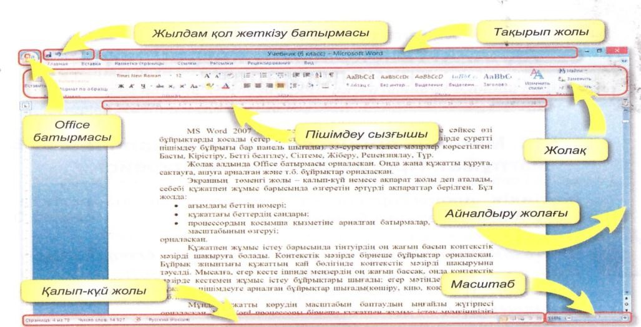
To start Microsoft Word, you must perform the following sequence of actions::
Create a new document: create a file.
Open an existing document: open a file.
Save Document: File – Save or File-Save As commands must be executed.

2) How does Microsoft WORD start the word processor?

3) name the window elements. (From the electronic textbook, task #3)
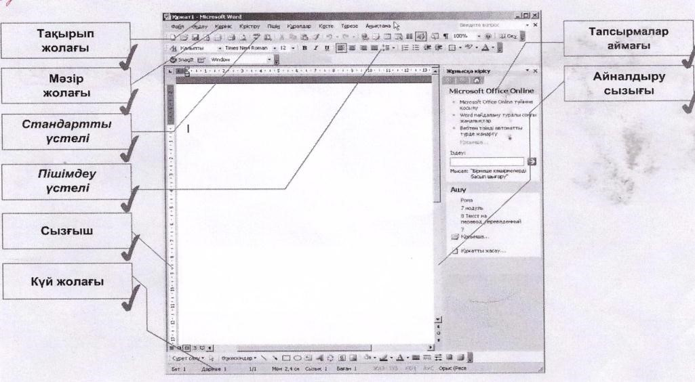

4) toning moment (Fizminutka)
5) Venn diagram.
Let's try to define the common properties of the Microsoft Word text processor and Microsoft WORD Pad.
1. text editor is it possible to save a document in a Microsoft WORD Pad and a Microsoft WORD Word Processor?
2. is it possible to create a table?
3. Can I replace the buffer?
4. can I fix the error?
5. is it possible to insert figurative text?
6. is it possible to print?

WORD

Word Pad

6) Approval.
"Find me" question and answer.

1)How does Microsoft run Word?
Answer: Microsoft's Push Program
Office MS Word

2) name the elements of the Microsoft Word Document window?
Answer: title bar, menu bar, standard table, formatting table, ruler, status bar
3) which menu command do we choose to create a new document? Answer: file-through the Create command
4) What menu command do we select to open a document? Answer: File-Open command.
5) What menu command do we choose to save the document? Answer: Save the File (Save the document)
6) What key can I use to insert a paragraph into the text? Answer: via The TAB key
7) How is everything capitalized? Answer: via the CapsLock key
8) What is an interval?
Answer: allows you to specify the distance.
9) when should I press the "ENTER" key when entering text? Answer: at the end of the paragraph
10) How do I disable a block of text?
Answer: you need to separate the block and press the "Delete" key
7.assessment of students ' knowledge. Assessment of students
8. homework assignment:
"General information about the word processor, the program interface.
Creation and storage of documents " read.
9. conclusion

